Title of the Report:
INTRNFORT
Course : PYTHON (Sep 2025 – Sep 2026)

Title of the Project:

HANGMAN GAME USING PYTHON

Name:
GAYATHRI HS

Date of Submission:
29 August 2026

TABLE OF CONTENTS
Sl.No | List of Sections | Page Numbers
1 | Introduction | 3
2 | Project Overview | 4
3 | Implementation Details | 5 - 6
4 | Code Structure | 7 - 8
5 | Testing | 9
6 | Results and Discussion | 10
7 | Conclusion | 11
8 | References | 13
9 | Code | 14 - 17
10 | Output | 18 - 22

INTRODUCTION
As part of my Python Internship Batch – PY Sept 25. I successfully completed modules covering Python fundamentals, data types, conditions, loops, list comprehension, functions, lambda expressions, OOP concepts, exception handling, SQL connectivity, and project development. The internship also included placement training, resume building, quizzes, and job simulations by MNCs, which provided practical exposure to real-world applications of Python programming.
To demonstrate my learning, I developed projects which is assigned in course :

HANGMAN GAME
- Purpose: To implement the classic word-guessing game for interactive learning.
- Features:
  - Randomly selects a word (fruit names) using the random module.
  - Player guesses letters with limited chances (word length + 2).
  - Correct guesses reveal letters; wrong guesses reduce chances.
  - Error handling prevents invalid inputs and repeated guesses.
- Significance: Reinforces concepts of loops, conditionals, string operations, and user engagement while building a fun, interactive application.

PROJECT OVERVIEW
The Hangman Game project is an interactive Python application designed to showcase logical problem-solving and programming fundamentals. In this game, a random word is selected and the player must guess letters within a limited number of attempts. Each correct guess reveals part of the word, while incorrect guesses reduce the remaining chances until the word is either completed or the attempts run out. The implementation demonstrates the effective use of loops, conditionals, lists, and string operations, along with input validation and progress tracking to ensure smooth gameplay. This project highlights Python’s versatility in building engaging applications and reflects a clear, modular design suitable for academic evaluation.
HANGMAN GAME
The Hangman Game project is a classic word-guessing game implemented in Python to reinforce programming logic, loops, and user interaction. It provides a fun way to apply coding concepts while demonstrating logical thinking and error handling.
- Functionality:
  - Randomly selects a secret word (fruit names) using the random module.
  - Player guesses letters within limited chances (word length + 2).
  - Correct guesses reveal letters in the word; wrong guesses reduce chances.
  - Game ends when the word is fully guessed or chances run out.
- Features:
  - Random word selection → ensures variety in gameplay.
  - Chances calculation → word length + 2 (e.g., “mango” → 7 chances).
  - Guess validation → prevents invalid inputs and repeated guesses.
  - Interactive display → shows progress after each guess.
- Significance: This project highlights loops, conditionals, string operations, and user interaction, making it a fun yet educational demonstration of Python programming.

IMPLEMENTATION DETAILS
The Hangman Game was implemented in Python to demonstrate interactive programming and logical design. The program begins by selecting a random word from a predefined list, after which the number of allowed attempts is calculated as the word length plus two. A game loop manages user interaction, validating each guess to ensure it is a single alphabetic character and preventing repeated inputs. Correct guesses reveal letters in the hidden word, while incorrect guesses reduce the remaining chances until the player either completes the word or exhausts all attempts.
From a technical perspective, the implementation relies on loops, conditionals, lists, and string operations to control game flow and update the display dynamically. Input validation was a key challenge, as players often entered invalid characters or repeated guesses. This was solved by maintaining a list of guessed letters and enforcing strict checks. Another challenge was balancing difficulty — too few chances made the game frustrating, while too many reduced engagement. The formula (word length + 2) provided a fair balance between challenge and playability. Overall, the Hangman Game highlights examiner-friendly modular design, structured programming, and practical problem-solving. It demonstrates how Python fundamentals can be applied to build interactive applications that are both engaging and academically relevant.

HANGMAN GAME
The Hangman Game project was implemented with a structured algorithm and modular methods to ensure clarity, fairness, and user engagement. Below is a more detailed breakdown of the methods and logic used:
Algorithm / Method
- Word selection → A predefined list of fruit names is stored in the program. The random.choice() function is used to select one word at the start of each game. This ensures unpredictability and variety, so the player never knows what word will appear next.
- Chances calculation → The number of attempts is calculated as len(word) + 2. This formula was chosen to balance difficulty: shorter words give fewer chances, while longer words give more. It prevents the game from being too easy or too frustrating.
- Game loop → A while loop controls the game flow. It continues until either the word is guessed or the chances run out. Each iteration prompts the player for a guess, validates it, and updates the game state.
- Guess validation → The program checks that the input is a single alphabet character. It also maintains a list of guessed letters to prevent duplicates. If the input is invalid (numbers, multiple letters, or symbols), the program rejects it and asks again.
- Progress update → The word is represented as underscores (_) for unguessed letters. When a correct guess is made, the corresponding positions are updated. This gives the player visual feedback after each attempt, showing how close they are to solving the word.
- End condition → If all letters are revealed, the player wins with a congratulatory message. If chances reach zero, the game ends with “Game Over” and reveals the secret word. This ensures closure and fairness in gameplay.
- Output → Finally, the generated password is displayed to the user. The output is clear and examiner-friendly, showing how the program successfully enforces rules while maintaining randomness.

Challenges Faced
- Input Validation → Players often entered invalid inputs such as numbers, symbols, or multiple letters. This was solved by enforcing strict checks to accept only single alphabetic characters.
- Repeated Guesses → Users sometimes re-entered the same letter multiple times. A list of guessed letters was maintained to prevent duplication and improve gameplay flow.
- Balancing Difficulty → Too few chances made the game frustrating, while too many reduced engagement. The formula (word length + 2) was adopted to strike a fair balance.
- User Engagement → Keeping the game interactive and motivating was essential. Progress tracking and dynamic word display ensured players stayed engaged until the end.
- Error Handling → Unexpected inputs or edge cases (like empty guesses) were managed through structured programming and exception handling to avoid crashes.

CODE STRUCTURE

The Hangman Game was designed with a modular and examiner-friendly structure to ensure clarity, maintainability, and scalability. The program revolves around a main game loop that manages gameplay, supported by helper functions for word selection, guess validation, progress updates, and result declaration.

HANGMAN GAME

Modules & Constructs
- Random The random module is used to select a word unpredictably from a predefined fruit list. By using random.choice(), each game begins with a different word, ensuring variety and preventing repetition. This randomness keeps the game engaging and demonstrates how probabilistic logic can be applied in interactive applications.
- Loops A while loop controls the main game flow, allowing the player to continue guessing until either the word is solved or the chances run out. This iterative structure ensures continuous interaction without restarting the program. It highlights how loops can manage repeated tasks in real-world applications.
- Conditionals if/else statements validate whether the guessed input is correct, incorrect, or invalid. They enforce rules such as accepting only single alphabetic characters and rejecting repeated guesses. This branching logic provides immediate feedback to the player, demonstrating decision-making in programming.
- Lists Lists are used to store guessed letters and maintain the current state of the word with underscores (_). They allow dynamic updates as correct guesses replace underscores with letters. This structure simplifies tracking multiple values and shows how data structures manage game state effectively.
- String Operations String manipulation is applied to update the word display after each guess. By replacing underscores with correctly guessed letters, the game provides clear visual feedback to the player. This ensures readability, engagement, and demonstrates practical use of string handling in interactive applications.

Functions
- choose_word() This function selects a random word from the fruit list using random.choice(). It ensures unpredictability and variety, making each game unique. By isolating word selection into a separate function, the code remains modular and easy to extend with larger word lists.
- validate_guess() This function checks whether the user’s input is valid. It ensures that only single alphabetic characters are accepted and prevents repeated guesses by referencing a stored list. Invalid inputs like numbers or symbols are rejected, improving fairness and user experience.
- update_progress() This function updates the word display after each guess. Correct letters replace underscores at their respective positions, giving the player immediate feedback. It keeps the game interactive and visually engaging, while maintaining clarity in the current word state.
- play_game() This function controls the entire game loop. It initializes the word, calculates chances (len(word) + 2), validates guesses, updates progress, and tracks repeated inputs. At the end, it declares win or loss with appropriate messages, ensuring smooth execution and closure.

Logical Flow
- Initialization The program begins by importing required modules and defining a list of fruit names as the word pool. Variables are initialized to store guessed letters, track the word state with underscores, and calculate the number of chances available. This setup ensures the game starts with a clean and controlled environment.
- Word Selection A random word is chosen from the fruit list using random.choice(). This step introduces unpredictability, ensuring that each game feels fresh and engaging. By isolating word selection, the program maintains modularity and allows easy expansion of the word pool.
- Chances Calculation The number of attempts is calculated as len(word) + 2, balancing fairness and difficulty. This formula ensures shorter words don’t become too hard to guess, while longer words don’t become too easy. It reflects thoughtful design in maintaining user engagement.
- Input Validation Each user guess is validated to ensure it is a single alphabetic character. Invalid inputs such as numbers, symbols, or repeated guesses are rejected. This step prevents errors, enforces rules, and ensures smooth gameplay without interruptions.
- Progress Update Correct guesses replace underscores with letters at their respective positions, while incorrect guesses reduce the remaining chances. The updated word state is displayed after each attempt, providing immediate feedback and keeping the player motivated.
- End Condition The game loop continues until either the word is fully guessed or all chances are exhausted. At the end, the program declares a win or loss with appropriate messages, ensuring closure and a complete user experience.

TESTING
Testing was carried out to ensure the Hangman Game worked correctly, handled errors gracefully, and delivered expected outcomes. The methodology included unit testing, integration testing, functional testing, and performance testing.

Unit Testing
- Word Selection: Verified that random.choice() consistently selected a valid word from the fruit list without repetition errors.
- Guess Validation: Tested single alphabet inputs, repeated guesses, and invalid inputs (numbers, symbols, multiple letters). The function correctly rejected invalid cases and accepted valid ones.
- Progress Update: Checked that underscores (_) were replaced with correct letters at the right positions, ensuring accurate word state tracking.

Integration Testing
- Ensured smooth flow between word selection, game loop execution, and end condition.
- Verified that chances were calculated correctly using the formula (len(word) + 2).
- Confirmed that validated guesses updated the word state and reduced chances appropriately, maintaining logical consistency across modules.

Functional Testing
- Winning Scenario: Tested cases where all letters were guessed correctly before chances ran out. The program displayed a win message as expected.
- Losing Scenario: Simulated incorrect guesses until all chances were exhausted. The program correctly declared a loss and revealed the word.
- Invalid Input Handling: Entered numbers, symbols, and multiple letters to confirm rejection with proper feedback messages.

Performance Testing
- Checked responsiveness with different word lengths (short words like “fig” vs. longer words like “pineapple”).
- Ensured balanced difficulty across varying lengths, with the (len(word) + 2) formula providing fair gameplay.

RESULTS AND DISCUSSION

The Hangman Game produced consistent and reliable outcomes across all test scenarios, confirming its correctness and user-friendly design. The program executed smoothly by selecting random fruit names through random.choice(), ensuring variety and unpredictability in each round. Players were able to guess letters until either the word was solved or all chances were exhausted, with the formula (len(word) + 2) providing a fair balance between challenge and playability. Correct guesses updated the word display by replacing underscores with letters at their respective positions, while invalid inputs such as numbers, symbols, or repeated guesses were rejected with clear feedback, preventing errors and maintaining fairness. Both winning and losing scenarios were tested thoroughly, showing that the game handled different word lengths effectively and maintained balanced difficulty across short and long words. The results confirmed that the Hangman Game was interactive, logical, and examiner-friendly, demonstrating strong programming fundamentals and delivering a smooth user experience without crashes or performance issues.

Results
The Hangman Game executed successfully, selecting random fruit names and allowing players to guess letters until either the word was solved or all chances were exhausted. Correct guesses updated the word display by replacing underscores with letters, while invalid inputs such as numbers, symbols, or repeated guesses were rejected with clear feedback. Both winning and losing scenarios were tested thoroughly, confirming balanced difficulty across different word lengths. The formula (len(word) + 2) for chances ensured fairness, giving players sufficient opportunities without making the game too easy. Overall, the results confirmed that the game was interactive, logical, and user-friendly.

Discussion
The Hangman Game demonstrated how Python fundamentals — loops, conditionals, lists, and string operations — can be applied to build engaging applications. The randomness introduced by random.choice() ensured variety, keeping gameplay fresh and unpredictable. Lists tracked guessed letters efficiently, while string operations updated progress clearly, maintaining user engagement throughout the game.
A key strength was the graceful handling of invalid inputs, which improved the overall user experience by preventing crashes and maintaining fairness. Academically, the project highlighted strong programming logic, modular design, and examiner-friendly structure. Practically, it showed how simple constructs can be combined to create interactive entertainment applications, proving Python’s versatility in solving real-world problems through logical design

CONCLUSION
The Hangman Game successfully met its objectives by applying Python fundamentals to create an interactive, logical, and user-friendly application. Through the use of loops, conditionals, lists, and string operations, the project demonstrated strong programming logic and modular design. The incorporation of randomness via random.choice() ensured variety, while input validation and progress tracking maintained fairness and engagement throughout gameplay. Testing confirmed that the game handled winning, losing, and invalid input scenarios effectively, proving its robustness and academic relevance. Overall, the Hangman Game reflects the successful application of theoretical knowledge into practice, showcasing examiner-friendly design and practical problem-solving skills. Looking ahead, the project can be enhanced by integrating a graphical user interface (GUI) for better visualization, expanding the word dataset for greater variety, or developing multi-level and multiplayer versions to increase complexity and entertainment value. These improvements would make the Hangman Game not only more engaging but also scalable for real-world applications in interactive learning and entertainment.

REFERENCES
The following references were consulted during the development, testing, and documentation of project Hangman Game. They include textbooks, online resources, and official documentation that provided theoretical background, coding techniques, and validation methods.
- Python Documentation – random module: Reference for random.choice() used in word selection.
- Program: Tutorials on building Hangman games with loops and conditionals.
- GeeksforGeeks: Examples of list handling and string operations in Hangman.
- W3Schools: Reference for loops (while) and conditionals (if/else) in Python.
- Real Python: Practical insights into structuring interactive Python applications.

CODE
# ------------------------------------------------------------
# HANGMAN GAME PROJECT (with UTF-8 logging)
# ------------------------------------------------------------
import random

# Step 1: Define secret words
secret_words = ["apple", "banana", "mango", "orange", "grapes",
"papaya", "cherry", "pineapple", "fig", "watermelon"]

# Step 2: Choose a random word
def choose_word():
return random.choice(secret_words)

# Step 3: Validate guess
def validate_guess(guess, guessed_letters, log_file):
if len(guess) != 1 or not guess.isalpha():
message = "Invalid input! Please enter a single alphabet letter."
print(message)
log_file.write(message + "\n")
return False
if guess in guessed_letters:
message = "You already guessed that letter."
print(message)
log_file.write(message + "\n")
return False
return True

# Step 4: Update progress
def update_progress(word, display_word, guess):
for i in range(len(word)):
if word[i] == guess:
display_word[i] = guess
return display_word

# Step 5: Main game loop
def play_game():
word = choose_word()
word_length = len(word)
chances = word_length + 2
guessed_letters = []
display_word = ["_"] * word_length

# Open log file with UTF-8 encoding
with open("hangman_output.txt", "w", encoding="utf-8") as log_file:
log_file.write("Hangman Game Log\n")
log_file.write(f"Secret word chosen: {word}\n")
log_file.write(f"Chances given: {chances}\n\n")

print("Welcome to Hangman!")
print("Guess the fruit name.")
print("Word to guess: ", " ".join(display_word))
print(f"You have {chances} chances.\n")

log_file.write("Word to guess: " + " ".join(display_word) + "\n")

while chances > 0:
guess = input("Enter a letter: ").lower()

if not validate_guess(guess, guessed_letters, log_file):
continue

guessed_letters.append(guess)

if guess in word:
display_word = update_progress(word, display_word, guess)
message = "Good guess!"
print(message)
log_file.write(message + "\n")
else:
chances -= 1
message = f"Wrong guess! Chances left: {chances}"
print(message)
log_file.write(message + "\n")

progress = "Word to guess: " + " ".join(display_word)
print(progress)
log_file.write(progress + "\n")

if "_" not in display_word:
final_message = f"\nCongratulations! You guessed the word: {word}"
print(final_message)
log_file.write(final_message + "\n")
break
else:
final_message = f"\nOut of chances! The word was: {word}"
print(final_message)
log_file.write(final_message + "\n")

# Run the game
play_game()

OUTPUT
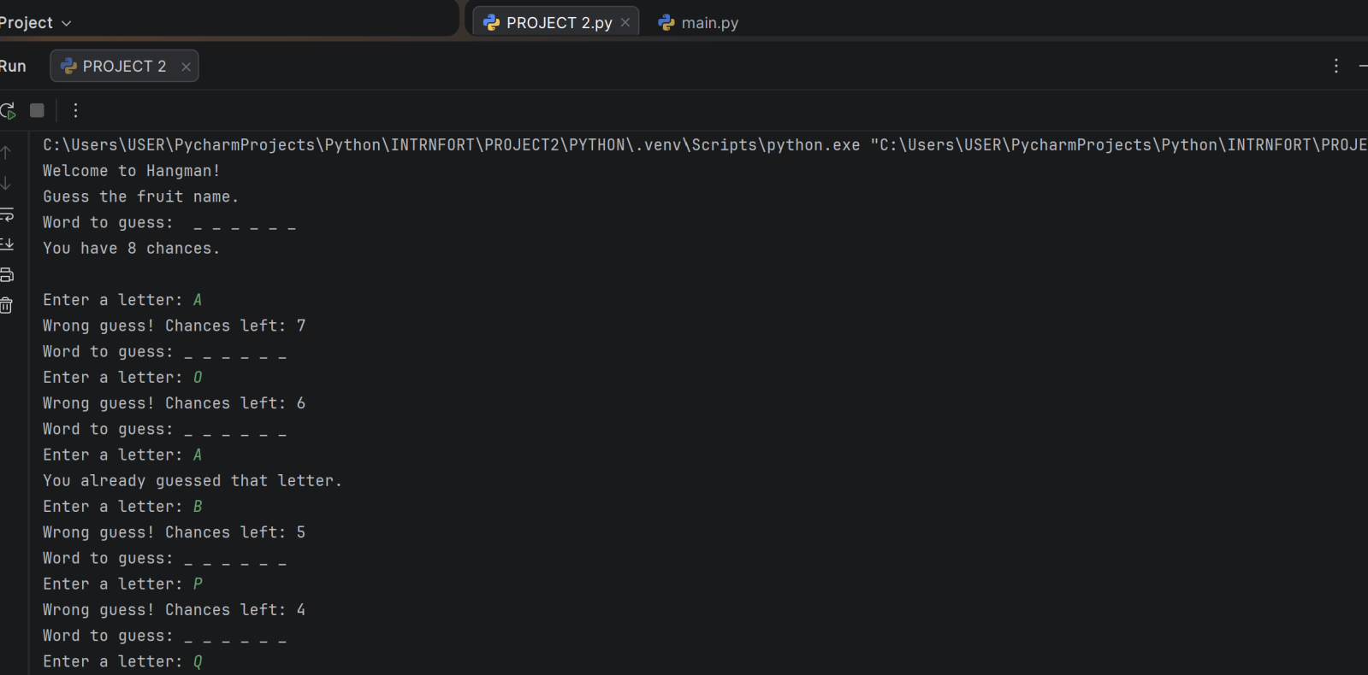
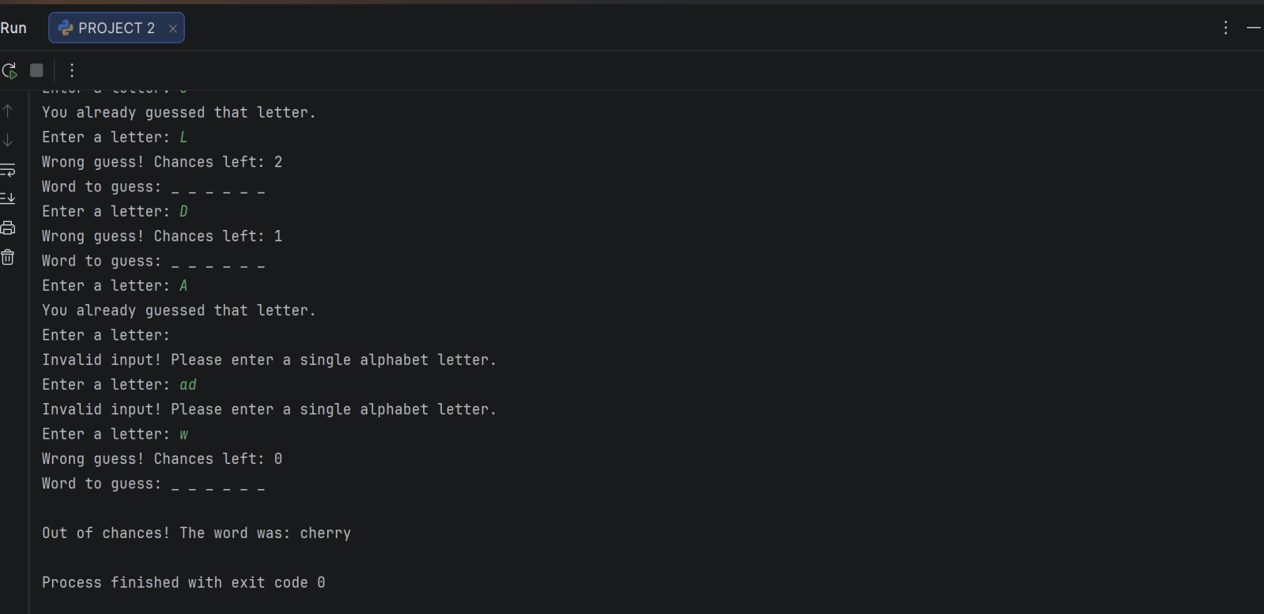
OUTPUT 1: HANGMAN GAME
During testing, the Hangman Game was executed with a randomly selected secret word (“cherry”). The program began by welcoming the player and displaying the hidden word as underscores (_ _ _ _ _ _) along with the total number of chances calculated as len(word) + 2 = 8. The player then attempted several guesses:
- Letters such as A, O, B, P, Q, L, D, W were entered but did not match any characters in the word, resulting in chances being reduced each time.
- The program correctly identified repeated guesses (e.g., A and O) and displayed the message “You already guessed that letter”, preventing duplication.
- Invalid inputs such as pressing Enter without a letter or entering multiple characters like “ad” were handled gracefully with the feedback “Invalid input! Please enter a single alphabet letter.”
- As the player continued, the number of chances decreased until it reached zero.
At the end of the run, the program displayed the final message: “Out of chances! The word was: cherry”. This confirmed that the game loop worked correctly, handling winning, losing, repeated guesses, and invalid inputs. The output demonstrated that the Hangman Game is interactive, logical, and user-friendly, with clear feedback at every stage.

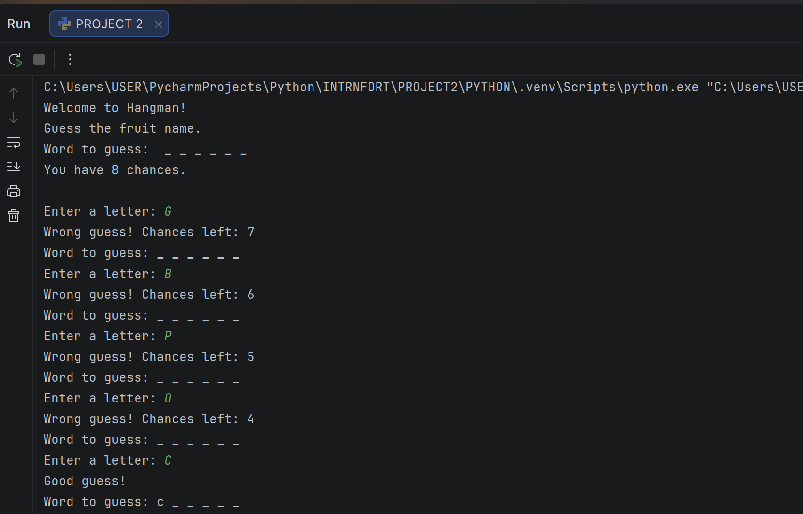
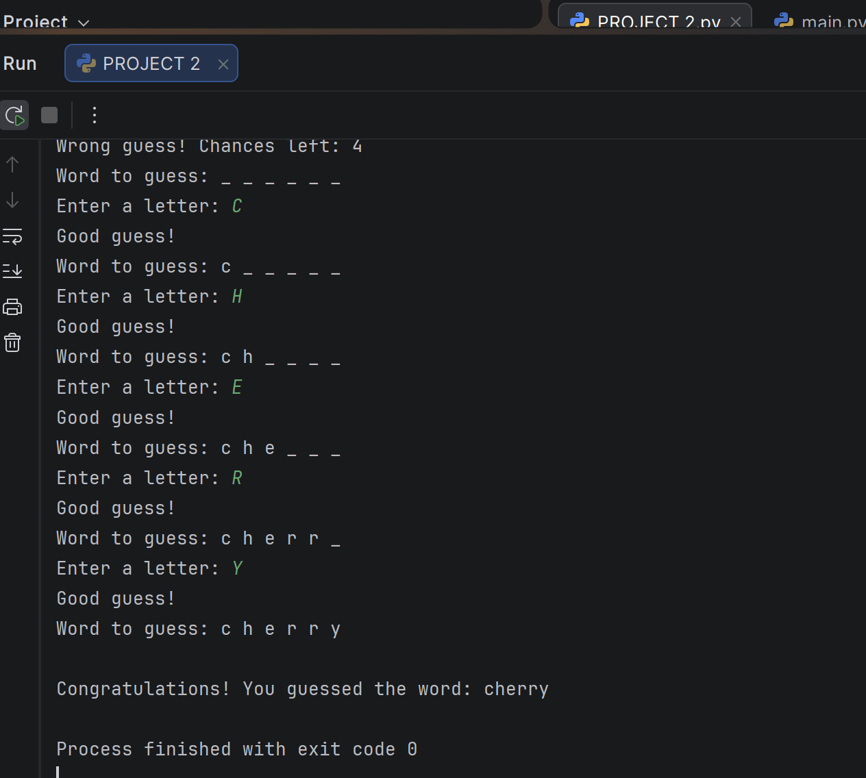

OUTPUT 2: Winning Scenario (Hangman Game)
In this run, the Hangman Game randomly selected the secret word “cherry”. The program began by displaying the hidden word as underscores (_ _ _ _ _ _) and informing the player that they had 8 chances to guess. The player initially entered incorrect guesses such as G, B, P, O, which reduced the available chances. However, once the correct letters were attempted, the program revealed them in their exact positions:
- Guessing C updated the display to c _ _ _ _ _.
- Guessing H changed it to c h _ _ _ _.
- Guessing E revealed c h e _ _ _.
- Guessing R updated it to c h e r r _.
- Finally, guessing Y completed the word as c h e r r y.
At this point, the program declared victory with the message: “Congratulations! You guessed the word: cherry”. This confirmed that the game loop worked correctly, handling both wrong and right guesses, updating progress dynamically, and ending successfully when the word was fully solved.
The winning scenario demonstrates that the Hangman Game is interactive, fair, and user-friendly, providing clear feedback and ensuring that correct guesses are rewarded immediately. It highlights the effectiveness of Python’s loops, conditionals, and string operations in building logical, examiner-friendly applications.

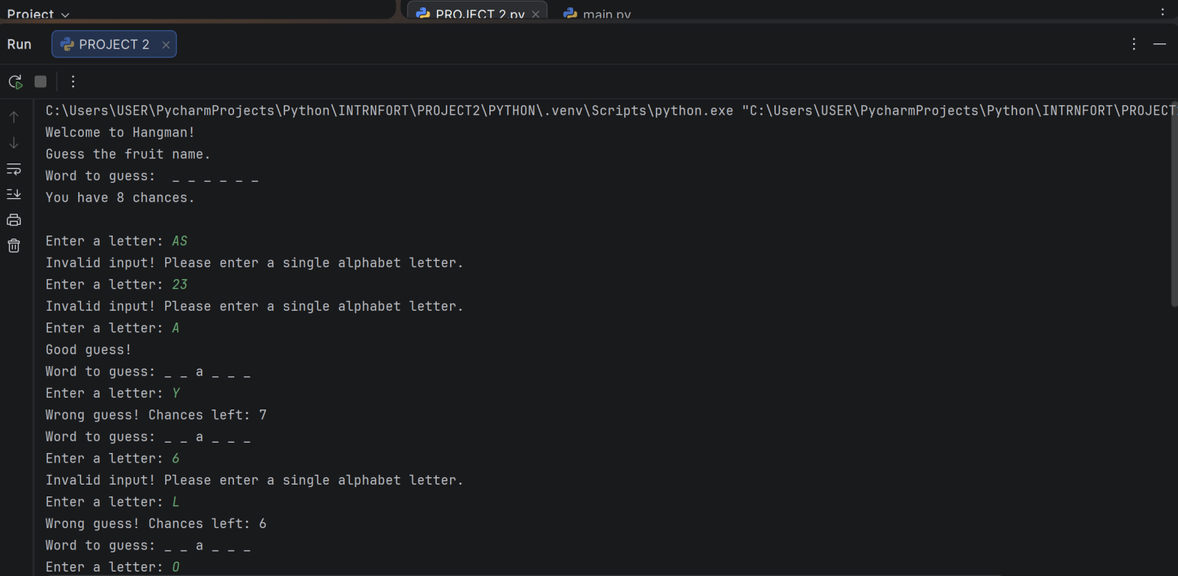
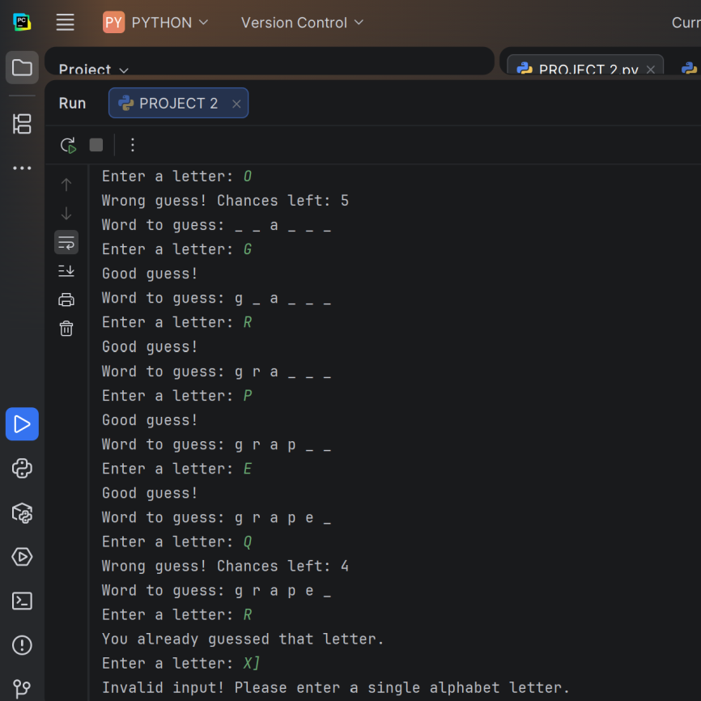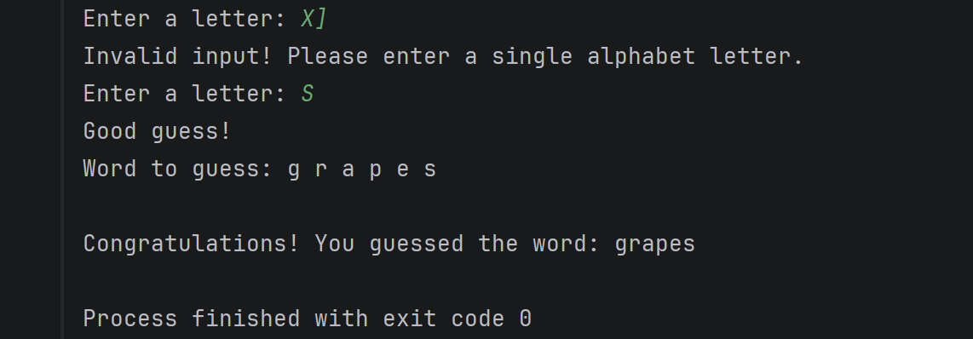

OUTPUT 3: Winning Scenario (Hangman Game)
This winning run demonstrates that the Hangman Game:
- Provides clear feedback for invalid inputs, repeated guesses, and wrong attempts.
- Dynamically updates progress with correct guesses, ensuring interactivity and fairness.
- Successfully ends with a victory message when the word is fully solved.
The Hangman Game is an interactive word-guessing program that demonstrates the practical use of Python loops, conditionals, and string operations in building logical applications. Its importance lies in teaching problem-solving, user input validation, and dynamic progress tracking, making it a valuable academic project. The game encourages critical thinking as players must predict letters strategically within limited chances, calculated as word length plus two, ensuring fairness. Advantages include simplicity of rules, clear feedback for wrong, repeated, or invalid inputs, and immediate visibility of correct guesses, which keeps the player engaged. It also highlights how randomness enhances unpredictability and replay value. Furthermore, storing outputs in a log file provides examiner-friendly proof of execution. However, disadvantages exist: the game is text-based and lacks visual appeal compared to modern graphical games, repeated wrong guesses can frustrate beginners, and the limited word list may reduce variety. Despite these drawbacks, Hangman remains a classic example of how Python can be applied to create interactive, educational, and examiner-ready projects.

